

- Written Date
The date the purchase order was created.
This is the date TIMS is sending to the supplier, but they should be sending the Approval date. No update as to when this will be fixed

- Original Approval Date
The date the order was 1st approved.
The date TIMS should be sending to the supplier

- Not Before Date/ Not After Date
The 1^{st /} last day that delivery of the order will be accepted
RWMS does receive these dates from RMS, yet there are only advisory, a "soft warning" when an appointment is made outside the window.
RWMS has an appointment window setting, currently set to 15. This allows RWMS to receive a PO 15 days before the NBD and 15 days after the NAD.

- Earliest Ship Date
The earliest date the items on a PO can be shipped by the supplier.
This date has no functionality; is not transmitted to the supplier or sent to RWMS.
From the Option menu > Dates, on the PO Header Maintenance screen, this date is populated with the POs Not Before Date when items are added to the PO.

- Latest Ship Date
The latest date the items on a PO can be shipped by the supplier.
This date is not transmitted to the supplier or sent to RWMS.
From the Option menu > Dates, on the PO Header Maintenance screen, this date is calculated from the Earliest Ship date + The number of days is configured in the Code Detail table (set to 1 for as a requirement for GO).
This date is what the Auto-Close batch program is reads as one of its criteria in determining if a PO should be closed.

At the end of September I sent out the steps to edit the POs fields "Latest Ship Date" and "Earlier Ship Date”
  - Select Items from the PO Header maintenance screen
  - Select VIEW > CUSTOM from the top left of the PO Item Maintenance screen
  - Click on the ‘+’ sign in the Customize PO Item Maintenance box
  - De-select 2 of the columns which are checked
  - Select Earliest Ship Date and Latest Ship Date
  - Click OK
  - The Earliest Ship Date and Latest Ship Date are now editable on the PO Item Maintenance screen
Note: The PO must be in Worksheet status to edit these dates.

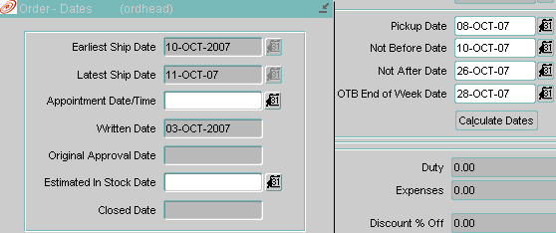

- Estimated In Stock Date
A calculated date, which estimates when an item on a PO is expected to be available.
Calculation =
Approval Date +
Supplier Lead Time +
Transit Days between Supplier and PO/Location +
Inbound handling days at the WH (if the PO location is a WH)

